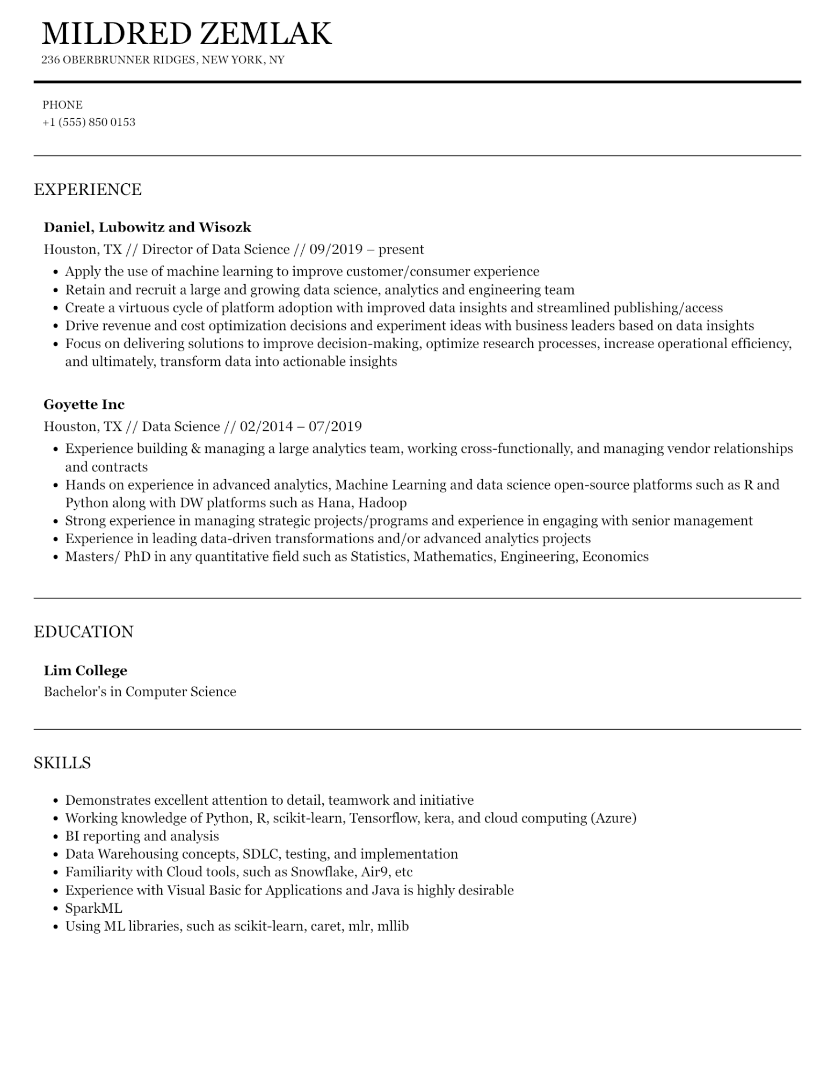
MILDRED ZEMLAK
236 OBERBRUNNER RIDGES, NEW YORK, NY
PHONE
+1 (555) 850 0153
EXPERIENCE
Daniel, Lubowitz and Wisozk
Houston, TX // Director of Data Science // 09/2019 – present
·
Apply the use of machine learning to improve customer/consumer experience
• Retain and recruit a large and growing data science, analytics and engineering team
• Create a virtuous cycle of platform adoption with improved data insights and streamlined publishing/access
• Drive revenue and cost optimization decisions and experiment ideas with business leaders based on data insights
• Focus on delivering solutions to improve decision-making, optimize research processes, increase operational efficiency, and ultimately, transform data into actionable insights
Goyette Inc
Houston, TX // Data Science // 02/2014 - 07/2019
•
Experience building & managing a large analytics team, working cross-functionally, and managing vendor relationships and contracts
• Hands on experience in advanced analytics, Machine Learning and data science open-source platforms such as R and Python along with DW platforms such as Hana, Hadoop
•
Strong experience in managing strategic projects/programs and experience in engaging with senior management Experience in leading data-driven transformations and/or advanced analytics projects
Masters/PhD in any quantitative field such as Statistics, Mathematics, Engineering, Economics
EDUCATION
Lim College
Bachelor's in Computer Science
SKILLS
• Demonstrates excellent attention to detail, teamwork and initiative
•
Working knowledge of Python, R, scikit-learn, Tensorflow, kera, and cloud computing (Azure)
• BI reporting and analysis
• Data Warehousing concepts, SDLC, testing, and implementation
•
·
Familiarity with Cloud tools, such as Snowflake, Air9, etc
Experience with Visual Basic for Applications and Java is highly desirable
·
SparkML
·
Using ML libraries, such as scikit-learn, caret, mlr, mllib

